
W W W . U N Q U I E T N I G H T S . C O M

"The kind of rock n' roll sorely missing from terrestrial radio these days"
- Indie Soup Runner
Unquiet Nights are a band with big ideas, big songs, and a big sound. With roots in Belfast and flavoured in London and Rome, the songs are ambitious and direct, whether you hear them live @ 10,000dB or on record. The music takes you back to a time when song-writing was king and Rock & Roll meant something.

Rising from the ashes of a previous Irish radio fixture, Unquiet Nights are centred on the songs of singer/guitarist Luke Mathers, the drum-work of Rodger Firmin, and the precision bass of John Rossi. It had always been about the songs, since long before anyone started taking notice. And now that they are taking notice, the thing being noticed is still the songs.

“We Were The Ones” – the pick of major US magazine Under The Radar in their Best of Year edition, “Burning The Tracks” the choice of Recharged Radio DJ Justin Wayne for track of the week, and “Shoulda Said Something” making the soundtrack of numerous sports segments worldwide, (Allisports, Surfline TV, ESPN). The songs have taken on a life of their own, picking up radio play in a long list of countries and drawing frequent comparison from DJs to R.E.M at their drive-time best, the lustful exuberance of The Rolling Stones & Primal Scream, and most pleasingly of all – Tom Petty & the Heartbreakers.

2011 so far has seen Unquiet Nights in Dublin (Balcony TV), London (Scala w/ Bloc Party), Italy (Live session for Radio Galileo) and headline shows in their hometown of Belfast. The first full album, “21st Century Redemption Songs”, is due for release in late 2011 and anticipation is growing steadily about that which is most essential to the band – the songs.

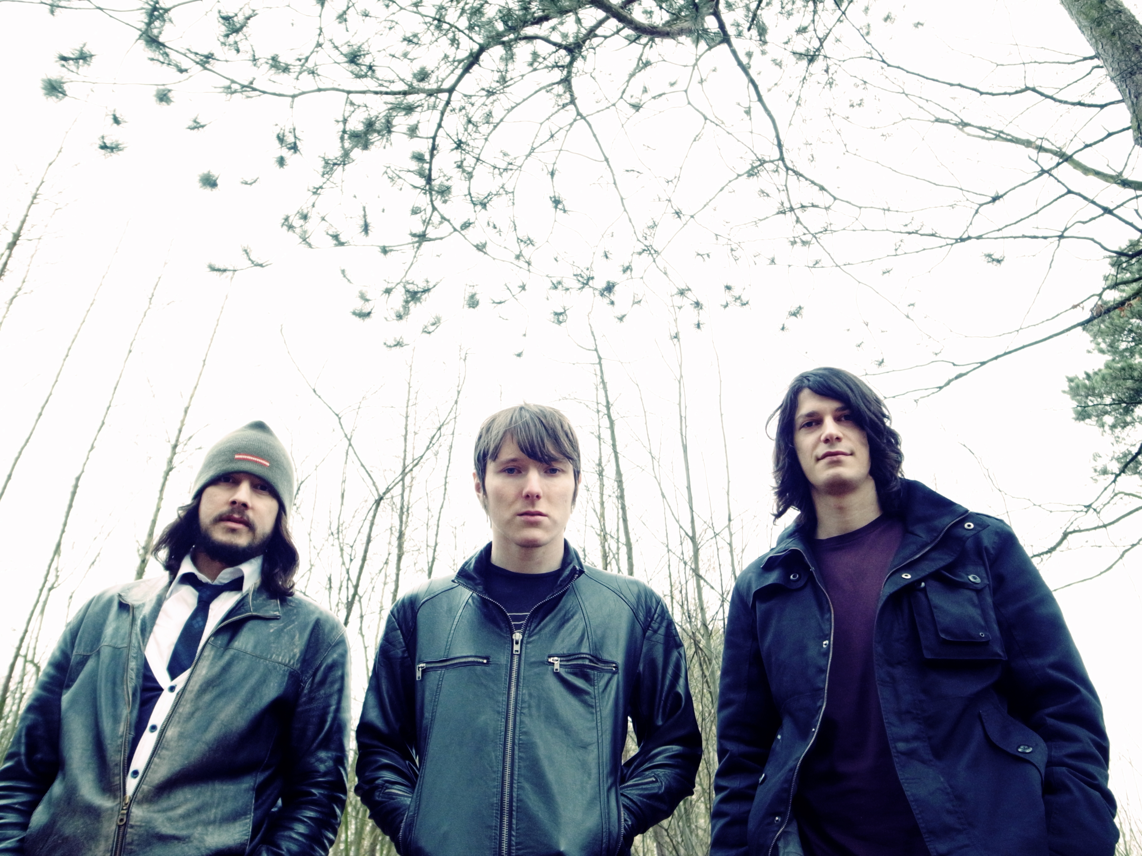
Unquiet Nights are the business. A kind of shining light in the Irish music world. - Dublinzine
unquietnights@hotmail.com
www.unquietnights.com
www.myspace.com/unquietnights
www.twitter.com/unquietnights
www.facebook.com/unquietnights
www.youtube.com/unquietnights
www.soundcloud.com/unquietnights
www.last.fm/music/unquiet+nights

